Canterbury Diocesan Board of Finance for the Parochial Church Council relating to:
The Living Well, Nonington

Parish Gift Aid Code: CDHAW Standing Order No:

Boost your donation by 25p of Gift Aid for every £1 you donate

Gift Aid is reclaimed by the charity from the tax you pay for the current year / Your address is needed to identify you as a current taxpayer

In order to gift aid your donations you must tick the appropriate box or boxes below

I want to gift aid my donations from this tax year onwards

I want to gift aid all the donations I have made in the previous four tax years.
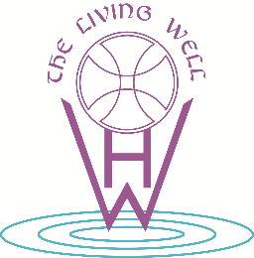
I am a UK taxpayer and understand that if I pay less Income Tax (and/or Capital Gains Tax) than the amount of Gift Aid claimed on all my donations in that tax year it is my responsibility to pay any difference.

Title First Name Surname

Home address

Postcode Date

You must sign this box to show you agree to your details being held securely by the parish and the diocese and being sent electronically to HMRC. They will be used for processing gift aid and for no other purpose. Your details will be retained for as long as required under the relevant Finance Act
_______________________________________

Please notify The Living Well if you want to cancel this declaration, change your name or home address or no longer pay sufficient tax on your income and/or capital gains

If you pay Income Tax at the higher or additional rate and want to receive the additional tax relief due to you, you must include all your Gift Aid donations on your Self-Assessment tax return or ask HM Revenue and Customs to adjust your tax code

GAD Number:

…………………………………………………………………………………………………………………………………………………………………………………….

Bank Standing Order Mandate

I wish to set up a standing order from my account at ___________________________________(name of bank) The account number is______________________________ and the sort code is_____________________

Please pay the sum of £…………… on the……………day of the month and continue monthly from this date until instructed otherwise.

Please pay the money to The Living Well -CDFH&W at Lloyds Bank. The sort code is 30-91-60,

and the beneficiary account number is 00094212 quoting (name…………………………………………………………………. )

If you need to clarify this instruction, then please contact me using the details you hold.

Name______________________________________________________________ Date______________________

Signature_____________________________________________________________________________________

